Some reflections on table construction
When you present a table in a report or a journal it is used for communication, not data storage. The data are stored in SPSS. Paper and print are meant for human eyes and human minds. Showing a table to your readers has a purpose. It is intended to help you tell your story and answer some of the management or marketing questions you have in mind. So the table design should be focused on giving these answers.

The following guidelines can help you. But keep in mind that design is choice. The theory consists of principles that generate design options and that guide choices among options. The principles should not be applied too rigidly; they are not logically or mathematically certain, and it is better to violate any principle than to place graceless or inelegant marks on paper.

Provide complete information
This implies that your table has a title that describes its content. There is proper labeling of the entries and of the units used, but leave out what is superfluous.
The source is mentioned (when appropriate).

Order the rows and columns in a way that makes sense
Two useful ways to order the data are:
  - Put the largest ones first. Often we look more carefully at what is on top and less carefully further down. So put the biggest thing first! Also, ordering by some aspect of the data often reflects ordering by some hidden variable that can be inferred.
  - Order things naturally. Time is ordered from the past to the future. An ordinal-scaled variable also has an intrinsic order. Showing data in that way melds well with what the viewer might expect.

Round – a lot!
This is for three reasons:
  - Humans cannot understand more than two digits very easily.
  - We can almost never justify more than two digits of accuracy statistically.
  - We almost never care about accuracy of more than two digits.

ALL is different and important
Summaries of rows and columns are important as a standard for comparison – they provide a measure of usualness. The type of summary we use to characterize ALL depends on the purpose. Sometimes a sum is suitable, more often a median or an average. But whichever is chosen, it should be visually different from the individual entries and set spatially apart.

Keep your design simple and professional
  - You have to decide about the font to use. It often works out fine if the font for the tables differs from the one you use in your text.
  - Try to make all columns the same width.
  - When outlining the figures per column (see the figure on the right) centered often works best.
  - Use cell coloring to replace (horizontal) gridlines. It makes reading easier.

And above all: Be consistent throughout your report.

In class we discussed two versions of a table made by some of our students. They are shown below. During our discussion we came up with a third version, improving on both options presented to the students.

Version 1:
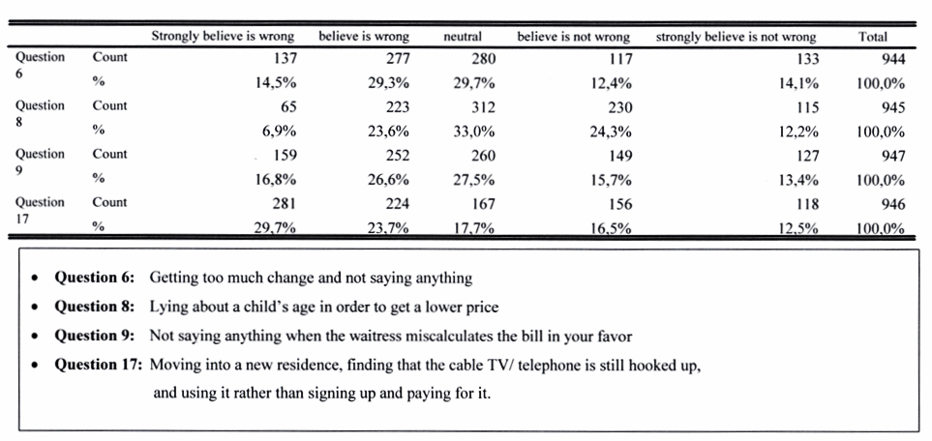

Version 2:
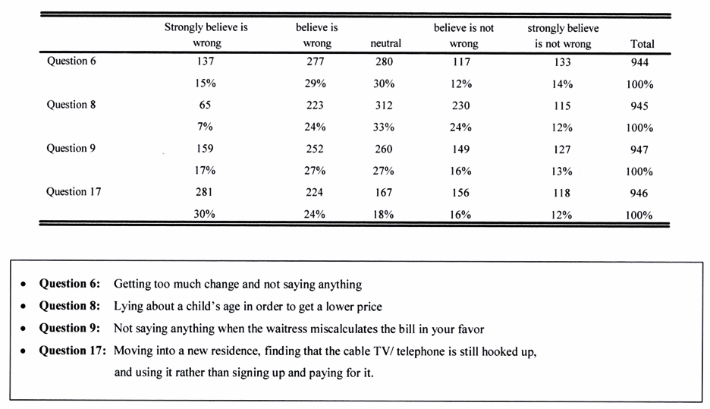

Our final result is shown on the next page. Some important considerations:
- We want the labels for the questions in the table, not in a footnote.
- We want to separate the numbers that relate to each question in a visual way
- We keep the column labels compact (wrapped over two lines) so the column widths are modest.
- We want a non-serif font.
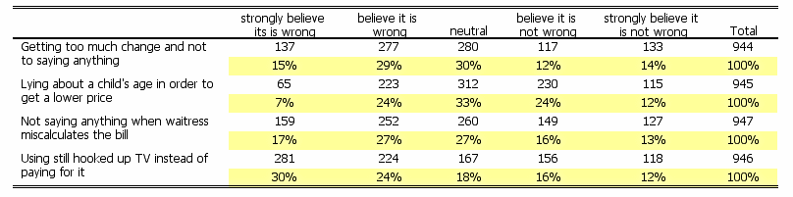

These reflections are in part adapted from Howard Wainer: Visual Revelations (1997, Copernicus, Springer-Verlag) chapter 10.

