**Some Reflections on the Design of a Pie Chart**

Unlike a table, the most important function of a statistical chart is to convey information visually. In chart designing there is a risk of unintentional distortion of the truth if the design principles are not properly applied. It is your responsibility to ensure that your chart gives an accurate and clear portrayal of the real character of the phenomenon concerned, i.e. that it conveys correct information.

A statistical chart is often better than a table for displaying the structural aspects of data, summarizing large amounts of data, demonstrating how things are connected, communicating ideas and conclusions and setting up a situation or feeling. What does a good graph need?

### Properties of a good graph

* Accuracy
* Simplicity
* Clarity
* Integrity
* Good Style
* Good Design

### Preconditions for a good graph

* Title: A short description of the depicted subject.
* Source: Where are the data from?
* Axes: Scale division and units of measurement are clearly stated.
* Legend: Key to the symbols if several phenomena are shown in the graph.

### A good graph has a high data-ink-ratio

Taking into account the size of the graphic in relation to the amount of data displayed yields the following ratio:

Data density of a graph = 

A good graph has a high data density.

After this general introduction let’s have a closer look at an example with a pie chart.

Below you find two versions of a pie chart showing the country of residence of the particip­ants in a consumer ethics survey.

Compare the two charts.

Find the differences and comment on them.

Which (aspects of which) version is better in your opinion? Why?

### Version 1

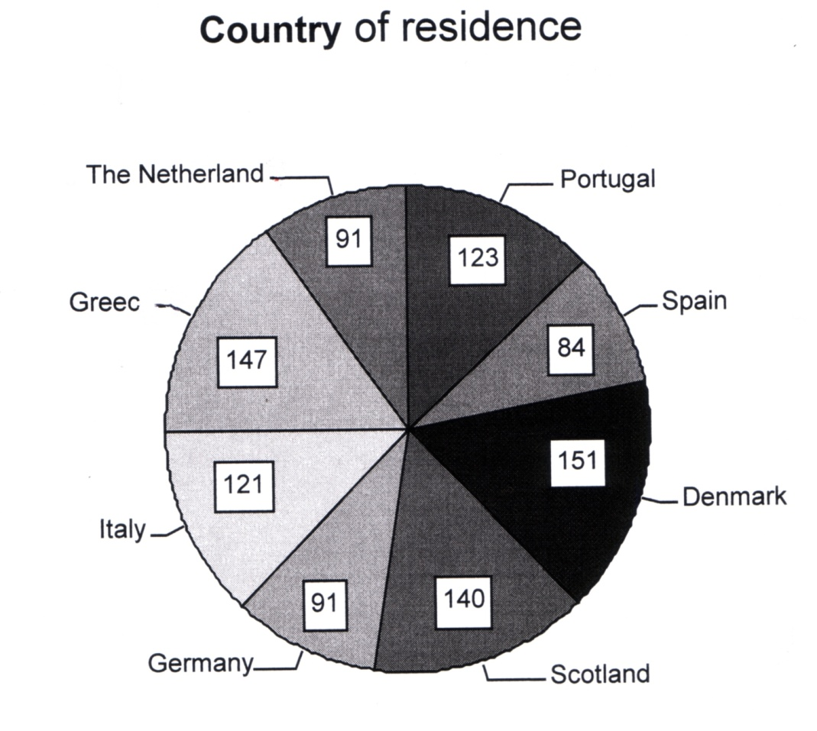

### Version 2

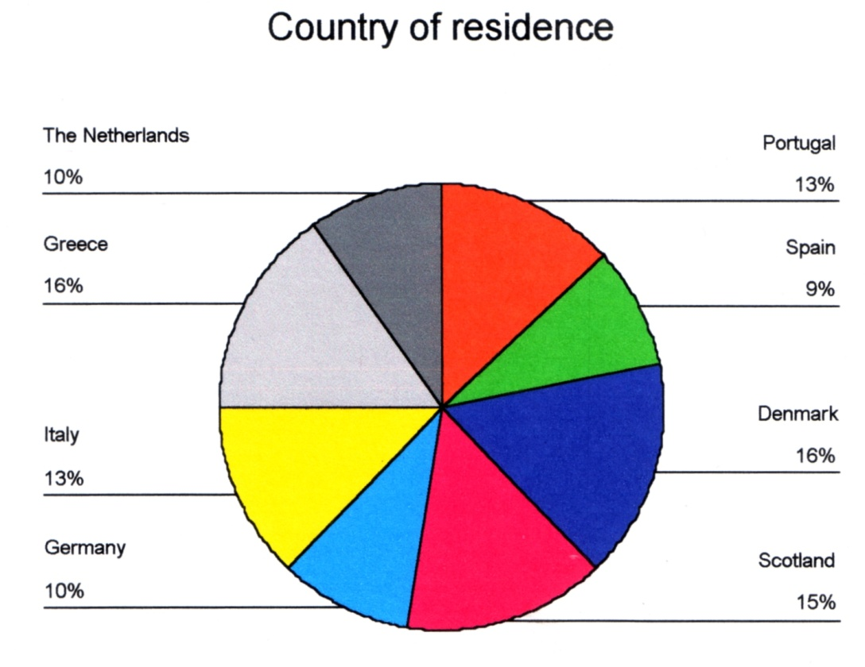

Some reflections:

* We want the readers to compare the sizes of the eight pieces of the pie. For that percentages are better suited than counts. But placing the numbers inside the pie slices works better than putting them outside.
* The spelling of the names of the countries is incomplete in the first chart. But the font size is better. In the second chart the print is rather small.
* Rounding percentages is a good thing. It has been done in version 2 of the chart. A minus point is that due to the rounding the percentages add up to 102% instead of 100%. There is nothing we can do about that in SPSS.
* Of course it would be nice to have the chart in color. If that is not possible then make sure that the shades of grey for adjacent slices are sufficiently different. Version 1 is better than a gray-scale print of version 2 in my opinion, although the difference isn’t that large and the labeling guarantees there will be no misunderstandings.

Conclusion: Neither of two charts is clearly the best. But we can have the best of both worlds and create a better third chart based on the two examples. We show you two options that came out of a class discussion.



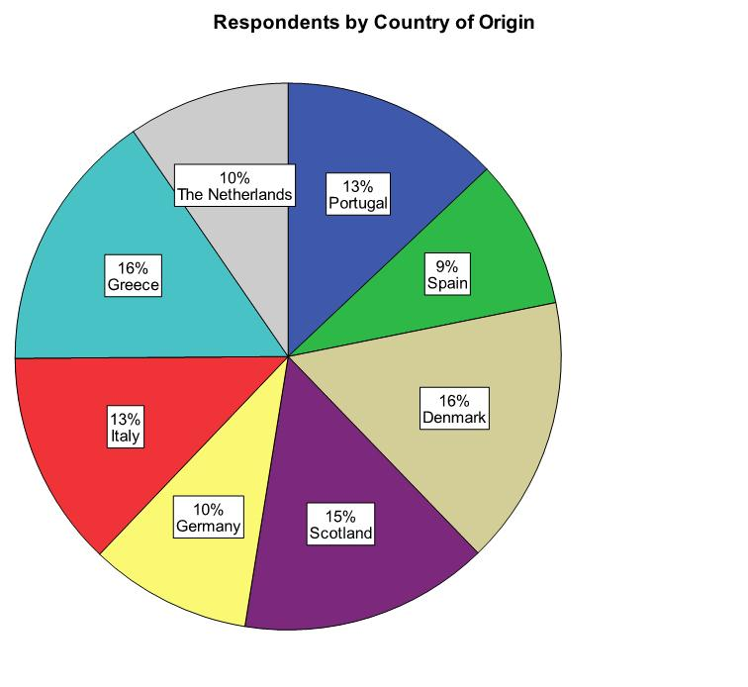

Note: Due to rounding the percentages add up to 102%.